**Use Case Definition: PAC-MAN:**

1. User starts the game and program shows the welcome screen with the request to hit spacebar to start the game.
2. User hits spacebar and the maze with the PACMAN, all the gold coins and the enemies are shown on the screen.
3. With a delay of few seconds PACMAN and all the enemies start moving.
4. User has 5 key interfaces, pressing one of the key at a time does the below listed functions;
   1. Up Arrow – Move the PACMAN upwards
   2. Down Arrow – Moves the PACMAN in the downward direction
   3. Right Arrow – Move the PACMAN in the right direction
   4. Left Arrow – Move the PACMAN in left direction
   5. Space Bar- Pause the game
5. All the four enemies move in random directions in the maze.
6. Special icons are placed at random positions in the maze during the gameplay one at a time, Collecting the icons provide special power to the PACMAN and gives extra points.
7. Moving the PACMAN with the keys, user collects all the coins and completes the game. If during collecting the coins PACMAN collides with any of the four enemies, PACMAN dies. User has three lives of PACMAN to complete the game.
8. If during the gameplay, user hits Spacebar, game is paused. User hits spacebar again to resume the game.
9. After the game is completes the screen displays the user’s score. User can close the game anytime by clicking on the top right corner (X).

2. User-Interface Diagrams:

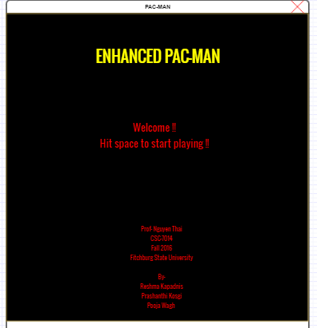

1. Startup Screen

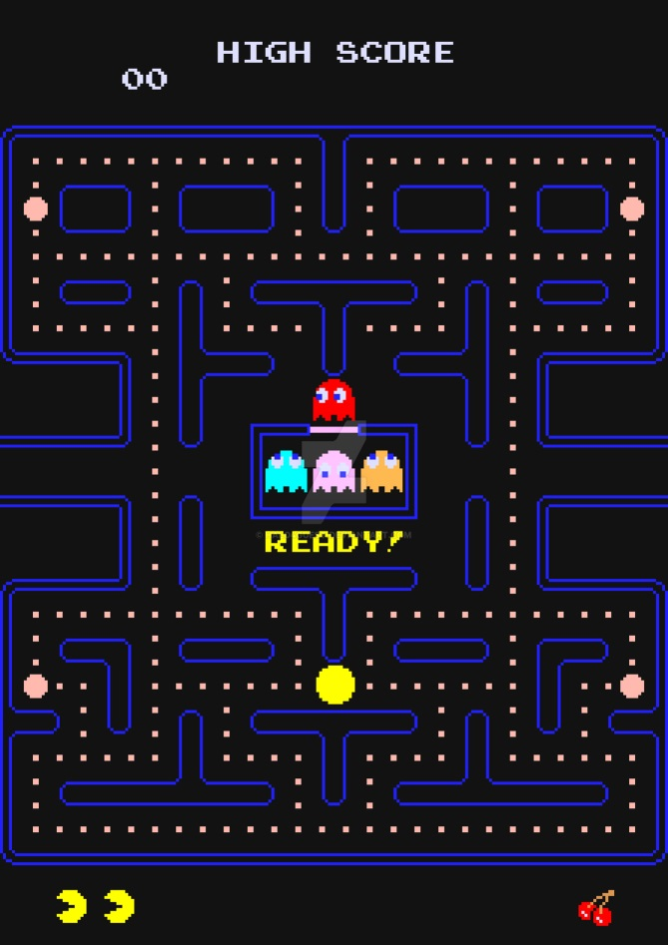

Fig B.

In fig. B After pressing the space bar, user can play the game.

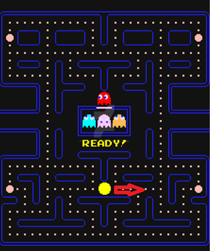

1. Input: Right Arrow

In fig c. When game starts Pac-man have to collect coins and for the movement of Pac-man, when user press the right button Pac-man moves to right.

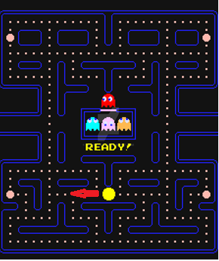

1. Input: Left arrow

In fig D. When user press the left button Pac-man moves towards left. For collecting the coins.

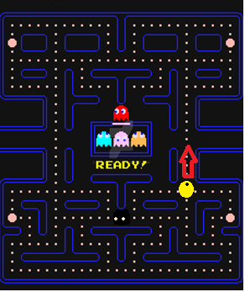

1. Input : Up arrow

Fig E. It shows the condition when user press the up arrow for the movement Pac-man will move upwards.

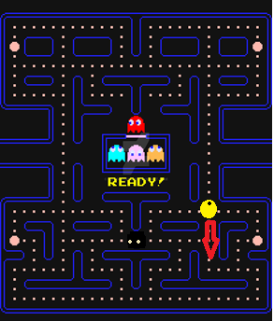

1. Input : Down Arrow

Fig f. It shows the condition when user press the down arrow for the movement Pac-man will move downwards.

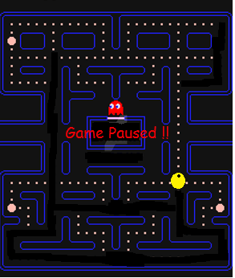

1. Input: Space bar

Fig G. When press the space bar while playing game automatically pauses and again pressing of space resume the game.

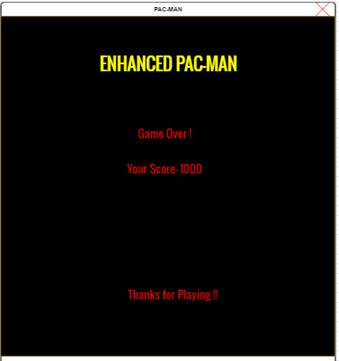

1. Game Complete

Fig H. When game will over it will show the closing window with score and “Game over” message on it.